CURRICULUM VITAE

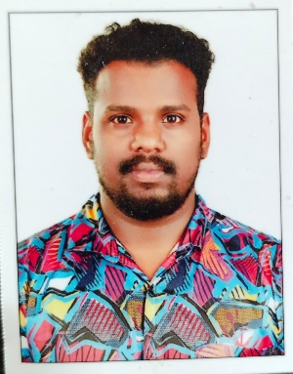

# MIDHUN HARI

Thayyil House SanthipuramP.O, Nedungadappally , Kottayam . 686545

Kerala, India

Mob : +916238427196

Email: [midhunhari1996@gmail.com](mailto:midhunhari1996@gmail.com)

# CAREER OBJECTIVE

Intend to seek a career within a progressive environment, which will capitalize on my accumulated knowledge and skills, and provide me an opportunity to learn and grow based on my performance and accomplishments.

# ACADEMIC QUALIFICATIONS

**ITI**

* Institute - Kanjirappally National ITI College
* Board/University - ITC
* Year of Pass - 2016

# Plus Two

* Institute - St. Marys School, kurichy
* Board/University - Board of Higher Secondary Examinations, Kerala
* Year of Pass - 2014

# S.S.L.C

* Institution - SB HSS , Changanacherry
* Board/University - Board of Public Examination, Kerala
* Year of Pass - 2012

**Passport Details**

* Passport Number : P5017385
* Date of Issue : 28/11/2016
* Date of Expiry : 27/11/26
* Place of Issue : Cochin

# EXPERIENCE

* 2018-2020, Worked as a technical Assiatant at kromberge & Scuhubrt in dubai
* 2021-Present , cab driver in kochi

## PERSONAL INFORMATION

Father’s Name : Hari VT

Age & Date of birth : 28,19/06/1996

Gender : Male

Religion : Hindu

Nationality : Indian

Marital Status : Married

Languages Known : Malayalam & English

## DECLARATION

I hereby declare that the information above mentioned is correct and true to the best of my knowledge and belief.

Place : karukachal **Midhun Hari**

Date : 08/08/2024